**Chapter 1**

**INTRODUCTION**

**1.1 General Introduction**

The person suffering from Alzheimer diseases finds it difficult to remember their own location and suffer from inability to recognize common things. People suffering from Quadriplegia sometimes cannot breathe properly and during this time their heart beat may go low or they may be uncomfortable at this time. In order to minimize the difficulties of people who are suffering from Alzheimer or Quadriplegia, this project proposed a method to help to locate Alzheimer patients when they venture outdoors. Also in the proposed project the Alzheimer patient health is monitored for heart monitoring and body temperature, so this data can be accessed by the android application.

**1.2 Statement of the Problem**

* Many older people forget someone’s name or misplace things from time to time. This kind of forgetfulness is normal.
* But, forgetting how to get home, getting confused in places a person knows well, or asking questions over and over can be signs of a more serious problem.
* The person may have Alzheimer’s disease, a progressive disease that destroys memory and other important mental functions.
* What is the current Heart Rate, temperature is difficult to monitor manually for this type of person.
* People suffering from Quadriplegia sometimes cannot breathe properly and during this time their heart beat may go low or they may be uncomfortable at this time.

**1.3 Objectives of the project**

The proposed method locates Alzheimer patients using RFID tags and GPS data. A prototype is proposed which is of an autonomous and wireless system which combines the two technologies and enables getting information’s about the position of Alzheimer patient from the intelligent tag. The body parameters like heart beat and body temperature are monitored and reported to doctor and relatives regularly.

**1.4 Project deliverables**

The deliverables of this project are as follows:

* A wearable prototype for monitoring the heart beat ,body temperature and location tracking of the patient.
* Each patient is uniquely identified with the use of RFID tag
* Prototype is embedded with a fall detection ,
* An android application which is installed on the patient care taker’s phone to monitor

health and to track current location using of the patient.

* In case of an event such as the patient falls down or his/her heartbeat rise beyond the normal range then an alert is triggered to the caretaker by sending a notification to the android application
* Raspi-Camera captures the image of location, where the patient met with event.
* Login to the application is provided to caretaker
* An option to clear the existing data in the android application is provided.

**1.5 Current Scope**

The concept is to attach an intelligent tag to the Alzheimer patient, and insert the reader in the exit. In case he/she tried to go out, his/her tag will be read and a message of warning will be send to the person in charge who can get all the information’s from the GPS module in the tag. Accordingly, the Alzheimer patient can be followed because of its location that is already known.

If the Alzheimer patient is not in indoor we switch to the GPS, turn it on and begin tracking. The RFID and GPS are attached to the asset for tracking and the position of the asset is recorded at regular intervals. The recorded location data can be stored within a tracking unit, or it may be transmitted to a central location data base, or internet-connected computer, using cellular (GPRS or SMS) modem embedded in the unit. This allows the asset’s location to be displayed in real time. The temperature sensor attached to the body of the patient will record the body temperature periodically and send to the main receiver controller. The controller will display the temperature along with time in which reading is taken. In the same way the heart monitor will track the heart beating and report same to controller regularly. In case of abnormal reading are recorded then the controller will detect the same display them in different color to high light the emergency situation the patient is facing. Since controller data is with family or with doctor, timely action on patient is taken and problem is averted.We are able to track the patient along with his/her current health status like as heart monitoring & temperature which play a key factor in our life.

**1.6 Future Scope**

Further this functionality can be extended to monitor various other parameter of the patient by including other sensors. The concept of radio Doppler Effect can be used so that by making use of radio wave, the patient’s vitals can be read instead of asking the patient to wear the prototype.

RFID Tag

GPS /GPRS

Raspberry PI 2

Wearable device

Heart Monitor

Temperature Monitor

Heart rate and temperature data can be analyzed

Data Base

Monitor \Laptop

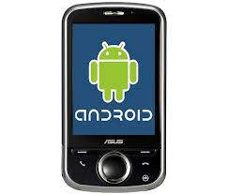

Monitor \Laptop



AWS

Figure: 1.2 Project Architecture

**Chapter 2**

**PROJECT ORGANIZATION**

**2.1 Software Process Models**

The purpose of this chapter is to ensure that the project is organized by explaining the software process development model that is used and what are the roles and responsibilities of the team members. Extreme programming, a type of agile methodology, is best suited for this project as the product is developed in small increments by using test driven development with the help of pair programming. Basically there are four phases in the project namely designing, coding, testing, and listening. The process of developing the software is divided between two people and the task of interfacing the hardware and coding in Embedded C is divided between two people. Once the individual modules have been unit tested and developed, then they are integrated together. As late changes in the requirements are allowed, the idea to choose Extreme programming process model to organize the project is justified.

The overall process in XP is shown in Figure 2.1 and iteration in XP is shown in Figure 2.2 respectively.

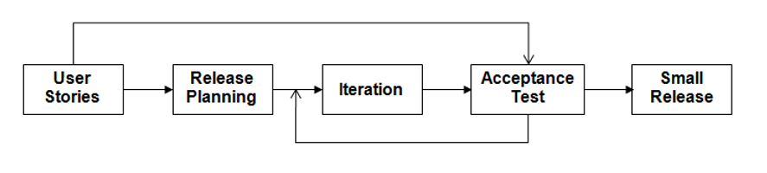

**Figure 2.1 Overall process in XP**

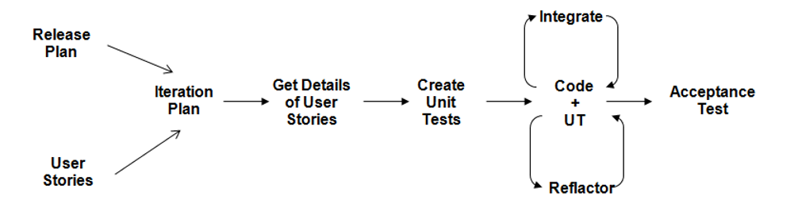

**Figure 2.2 An iteration in XP**

**2.2 Roles and Responsibilities**

* Manoj More S is the Team Leader and was instrumental in conducting brain storming sessions to determine the possibilities of extending and improving the project. Also he was responsible for purchasing the necessary hardware components, assembling the circuit and also helped in designing the prototype.
* Suhail TN’s role was to prepare the report and also helped Suresh in developing the Android application. Also he suggested the idea of using a microcontroller than any IOT device such as Raspberry pi as internet connectivity cannot be expected to be present all the time. Further he also carried out the literature survey.
* Suresh V was responsible for coding the Android application and also to perform unit testing of GPRS module. Also he determined what sensors and other hardware components will best suit the project and played an important role in delegating work among the team members and prepared the project management plan.
* Himanshu Kumar’s role was to perform integration testing and deployment. Further

He coded the necessary hardware programs using Embedded C for interfacing the GPRS and for flashing the Embedded C code into the Renesas RL78 microcontroller in addition to determining the software requirements specifications and also integrated the amazons web service with the Raspberry pi.

**Chapter 3**

**3. LITERATURE SURVEY**

**3.1 Introduction**

Monitoring healthcare in current generation is to be given an utmost importance. This project keeps track of Alzheimer’s and Quadriplegia patient vitals. The proposed method locates such patient and tracks vitals such has heart beat and body temperature to ensure better care of patient in critical situation. A individuals vitals are available on the android application, so that doctor and patient’s guardian can keep track of patient’s status.

**3.2 Related Works with the citation of the References**

Automated Health Alerts Using In-Home Sensor Data for Embedded Health Assessment [12] will continuously monitor the home for the purpose of assessing early health changes. Sensors embedded in the environment capture behavior and activity patterns. The major advantage here is this method keeps track of vitals but this makes use of multiple embedded sensor which are supposed to be install at all over the home, which result in more power consumption and this implementation is expensive. Instead of installing the embedded sensors all over the home, proposed method has one embedded sensor to keep track of individual person. In proposed system the concept of wireless sensor network [13] is implemented so the patient’s vitals in available in laptop which is virtually connected to the embedded sensor board, by this setup the embedded board can be can be accessed via GUI interface and reprogrammed.A Smart System connecting e-Health Sensors and the Cloud [14] this method is using the AWS services for data storage and analytics. The proposed system uses AWS service where cloud desktop instance is created using EC2 service .In Cloud desktop instance uses the RDS service for the data storage purpose, and TCP listener application captures the data sent from the embedded board and form the data to the android application using the port number 85.

In[14] the advantage was using AWS services for the storage and analytics but the data stored where not forwarded to doctor or patient guardian, but in proposed system we made use of cloud desktop server and android application so that patient real time data is available on mobile devices. A Wireless Tracking System for At-home Medical Equipment during Natural Disasters [15] described about accessing real time location of medical equipment which was again waste of resources, because method comes into picture only when natural disaster occurs. Only in order to keep track of medical equipment the power consuming method is used. But in proposed system we use the method to keep track of the patient location. The white paper of the Structured monitoring product [16] is referred has a part of proposed system future enhancement, Where the concept of the Doppler effect can be used to eliminate the physical contact of sensor with the human body, data vitals are read through the wireless connectivity.

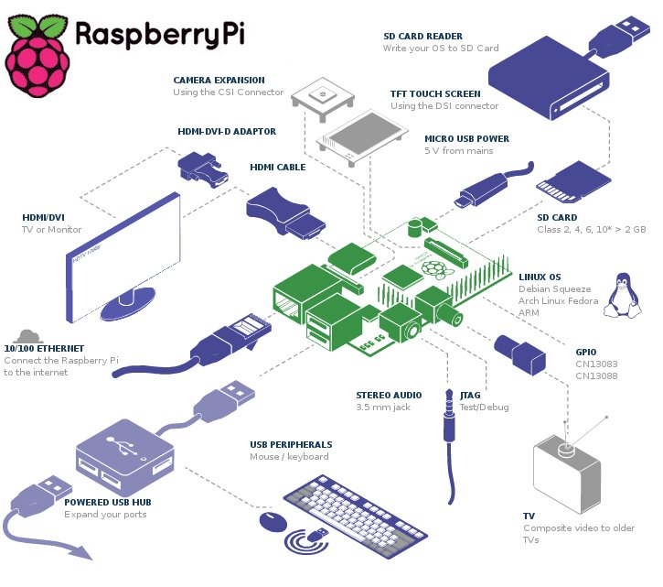

Figure: 3.1 System Architecture

**3.3 Conclusion**

The system that we have proposed is light weight and can be used on a daily basis and will help in quick recovery. We presented an approach for Alzheimer patient tracking using the RFID tags and the GPS. We presented a system allowing having the relative position of the tag. Additionally we described how we can locate using the advantage of each technology. We furthermore present how to fabricate both of the elements: the tag and the reader. Finally, in practical our system can at the same time detect and build accurate maps sending data continually, otherwise knowing the position in real-time of people with Alzheimer disease. We are monitoring temperature and heart beat continuously . By sending an Email alert to the caretaker along with the GPS position of the user it ensures that the user receives immediate care.

RFID Tag

GPS /GPRS

Raspberry PI 2

Wearable device

Heart Monitor

Temperature Monitor

Heart rate and temperature data can be analyzed

Data Base

Monitor \Laptop



Monitor \Laptop



AWS

Figure: 3.2 Proposed System

**Chapter 4**

**PROJECT MANAGEMENT PLAN**

**4.1 Project Schedule**

This chapter deals with scheduling the project using Gantt chart and risk identification and steps taken to mitigate these risks.

The overall project schedule is briefly summarized in Table 4.1.

|  |  |  |
| --- | --- | --- |
| **Sl. No.** | **Task Name** | **Duration** |
| 1. | Problem Definition | 6 days |
| 2. | Project Plan | 7 days |
| 3. | Requirements Gathering and Analysis | 7 days |
| 4. | Design | 7 days |
| 5. | Implementation | 34 days |
| 6. | Testing | 4 days |
| 7. | Documentation | 6 days |

**Table 4.1 Project Schedule**

Table 4.1 has been summarized from the Gantt chart drawn for the project. A Gantt chart is effective in scheduling a project and graphically representing the deadlines and the tasks which are pending and those which have been completed. The Gantt charts are shown in Figure 4.1 and Figure 4.2 respectively on the next page. As we can see the main tasks include problem definition, project plan, Requirements gathering and analysis, Design, Implementation, Testing and Documentation. Each of these tasks in turn have some sub tasks under them.

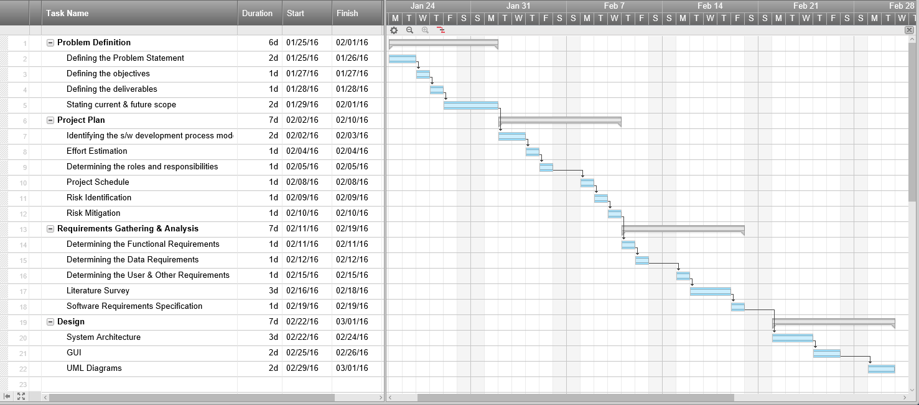

**Figure 4.1(a) Gantt chart**

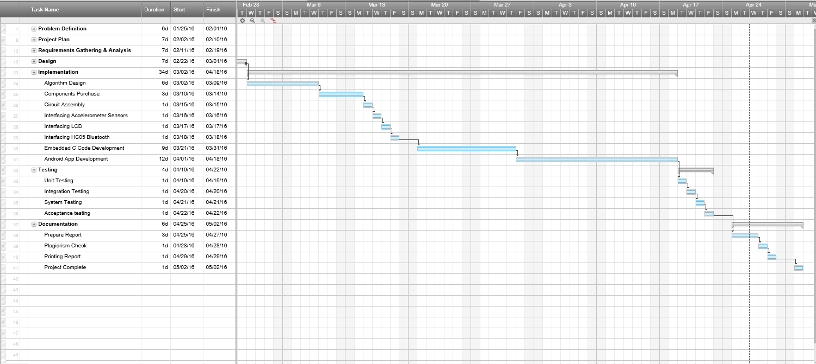

**Figure 4.1(b) Continuation of Gantt cha**

**4.2 Risk Identification**

The top five risks for this project along with the mitigation steps taken for each of them are summarized in Table 4.2.

|  |  |  |
| --- | --- | --- |
| **Sl. No.** | **Risk Item** | **Risk Mitigation Techniques** |
| 1. | Developing the wrong software functions. | Early user manuals, User surveys and developing the software in iterations (prototyping). |
| 2. | Developing the wrong user interface. (Android Application) | Task Analysis, User Characterization, Scenarios and Prototyping. |
| 3. | Changing project requirements. | Developing the software in small increments. |
| 4. | Lack of technical and management skills. | Adequate training and also allocating tasks to people based on their capabilities and strengths, enhanced communication between team members |
| 5. | Use of non-effective hardware components. | Clearly understanding the requirements and analyzing the scenarios, requirements scrubbing, cost benefit analysis. |

**Table 4.2 Risk Identification and Mitigation**

**Chapter 5**

**SOFTWARE REQUIREMENT SPECIFICATIONS**

**5.1 Product Overview**

The aim of this product is to build an Android application which can monitor the heart beat ,fall detection and tracking current location of the patient with the help of Renesas RL78 MCU ,heart beat sensor, temperature sensor and fall detection sensor. A GPRS module is used for transferring data between the MCU and the Android Application. When the patient heart beat rises beyond normal range or when he/she fall down then an alerts the intended recipients via android application. Further the prototype to be built is wearable.

**5.2. External Interface Requirements**

5.2.1 User Interfaces:

The user interface includes an Android Application. The android application will be highly interactive, efficient, and attractive but would yet be simple and possess a sleek look. Also this interface will be highly user friendly and will perform two important tasks. One task is keeping track of real-time medical related data. Another task is that it would enable the user to keep a location and this would be helpful for analysis and speedy recovery. The remote system displays the voltage value that is produced as the output by the Raspberry pi 2 for the corresponding sensor inputs .The user interface shall be implemented using Java and a framework like Android Studio. A web application to can be implemented where alerts are triggered to keep the relatives informed in case of emergency events.

5.2.2 Hardware Interfaces:

The hardware interfaces will include the need of wireless internet connectivity to send Gmail Alerts in case of unforeseen emergency events and also to update the Web Application. Raspberry pi 2 is the hardware device which is responsible for co-coordinating various activities with respect to the project and is the core component. Further heart rate sensors are used to measure the change in heart rate and its output is fed to the input of the Raspberry pi 2. A wireless module must also be interfaced.

5.2.3 Software Interfaces:

The values are sensed from the heart rate sensors which are then fed to the Raspberry pi 2. An assembly language or python program is written and embedded into it to covert the sensor value to a corresponding voltage value as its output. Further Java and a framework like Android Studio will be used to develop the Android Application and also to send the intended Gmail Alerts to the doctor. Further CSS, HTML5 etc. can be used to develop the Web Application which runs on an Apache Tomcat Server.

5.2.4 Communication Interfaces:

SMTP is the communication protocol used to send Email Alerts to the doctor which uses port number 25. Further for the Web Application HTTP protocol is used which runs on port number 80. Also a Wi-Fi signal is used as the communication interface between the wearable computing kit and the Android Application running on the mobile device of the user and monitoring system.

**5.3. Functional Requirements**

5.3.1 Functional Requirement 1.1: Tracking of the Real time location

The GPSR module will help to keep track of the real time location of the person who is under the monitoring.

5.3.2 Functional Requirement 1.2: Email Alert

In case if emergency condition, The Gmail Alert is sent to the doctor and the concerned guardian.

5.3.3 Functional Requirement 1.3: Online Monitoring

The values sensed by the heart rate sensors can also be monitored online with the help of a web application. This is particularly helpful when the user is alone and others want to monitor his/her status.

5.3.4 Functional Requirement 1.4: Android notification

The user is provided with an Android application interface to keep the alerts and also to be updated.

5.3.5 Functional Requirement 1.5: Maintaining History

The Web Application also maintains a log/history of the sensed values which be accessed at any time.

5.3.6 Functional Requirement 1.6: Analysis of Data

The Analysis of data will give the prediction over the health status , Also Android application can also be used to view the complete analysis of data that has been collected.

**5.4. Software System Attributes**

5.4.1 Reliability:

The reliability of the product depends on the lifetime of the heart rate sensors and the accuracy of the measurement. As lifetime and accuracy is high the system is reliable. Further the android application would be rigorously tested to ensure that the application does its intended tasks in real time and doesn’t generate fake alerts due to some bugs.

5.4.2Availability:

The basic functionality of the system except the Gmail Alerts and Web Application is always available as long as the device is worn by the user. For Gmail Alerts and Web Application updates internet connectivity is needed.

5.4.3 Security:

The scope for security in this product is more over concerned with privacy. Only the authorized phone of the user must be capable of receiving the alerts and more over the data readings stored in the web application must be kept safe and thus authentication and authorization can be added. The system shall not leave any cookies on the customer’s computer containing the user’s password. The web browser shall never display a user’s password. It shall always be echoed with special characters representing the typed characters.

5.4.4 Portability:

One of the features of Java is that it is architecturally neutral i.e. the code is machine/platform independent. Thus the same application can run on different Android phones and its backward compatible with respect to a specific Android phone version. Also the Web application can be accessed from a variety of browsers.

5.4.5 Performance:

The product’s performance is measured in terms of responsiveness, efficiency and user experience. A product with high performance will be delivered. Performance is high if the throughput is high, latency is low, response time is less and system dependability exists. The changes in the angle of the knee joint must be measured with accuracy and also in real time. Performance is also affected by the speed of internet connectivity for updating the web application and also for sending Email Alerts.

5.4.6 Maintainability:

The Android application needs to maintained and updated in case of any bugs. Updated applications will be free from bugs and also some design oriented changes can be incorporated to make the interface more user-friendly and attractive.

**5.5. Performance Requirements**

The only way in which systems will meet their performance targets is for them to be specified clearly and unambiguously. It is a simple fact that if performance is not a stated criterion of the system requirements then the system designers will generally not consider performance issues. In order to assess the performance of the product the following are clearly specified:

**Response Time**- It depends on the Raspberry pi 2 used as it needs to execute the embedded program to convert the sensor value into a voltage signal and then needs to transmit the Bluetooth signal. The response time needs to be low.

**Workload**- Even if the workload on the system is increased the performance doesn’t degrade as Raspberry pi 2 has 16bit CISC architecture. Raspberry pi 2 is designed specifically for ultra-low power applications enabling customers to build low cost system.

**Scalability**- The product is highly scalable as it can be worn by various users and all that they need to do is to install the Android application on their phone.

**Platform-** The Raspberry pi 2 is that uses 16bit CISC architecture and the Android application is built using Java and a framework like Android Studio.

**5.6. Database Requirements**

A database is used to provide persistent offline storage as it keeps a log of the values sensed by the heart rate sensors along with the date and time. The database used needs to be a relational database, for example MySQL can be used or we can make use of Amazon web services for persistent storage.

**5.7. Design Constraints**

1. **Space**: The amount of space occupied by the embedded program must be less as it needs to be incorporated into the Raspberry pi 2. Further the android application must be of size less than 100MB.
2. **Application memory Usage**: The amount of memory that is cache as well as main memory used must be low while executing the embedded program. This is to meet the requirements of the Raspberry pi 2.
3. **Budget**: The amount of money that can be spent on the hardware must be less than Rs6000/- so that the price of the overall is quite reasonable.
4. **Application Quality:** The quality of the product must be good and also it must be comfortable to wear it.

**5.8. Other Requirements**

1. **Help:** A detailed user manual which is easy to follow must be developed and also an online demonstration of how to use the product must be available.
2. **Android version:** The application developed must be simulated on the latest Android version and also it needs to be backward compatible

**Chapter 6**

**DESIGN**

**6.1 Introduction**

In order in to optimize the design process and also to ensure that the design is efficient and the final product designed meets the desired requirements and achieves the goals and objectives of the project, it is essential to divide the project into various components or modules whose description has to be defined clearly.

Thus this chapter initially describes the different modules present in the project. Later the system architecture is described which is followed by the description of the GUI and then various UML diagrams like class diagram, sequence diagram and data flow diagram are given.

The different modules needed and their description for Smart Health Care Monitoring system are given below

**1. Heart Beat Sensor Module**: This module is responsible for identifying the change in heart rate, The Heart Beat Sensor provides a simple way to study the heart's function. This sensor monitors the flow of blood through Finger. As the heart forces blood through the blood vessels in the Finger, the amount of blood in the Finger changes with time. The sensor shines a light lobe (small High Bright LED) through the ear and measures the light that is transmitted to LDR. The signal is amplified, inverted and filtered, in the Circuit. Usually Heart rate will be calculated for 1Minute. For a healthy human being we get heart rate of 72 pulse rate per 1 minute. For real time applications we cannot wait for 1minute each time because if there is any disturbance in calculating for ex: if patient is not properly keep his finger inside the device means again we have to take the readings. For this we are following averaging & sampling method. In this we are calculating heart rate for each 5 seconds & we are replacing that value in array of 12 characters. After replacing each value we will add the entire array. After the 12th value we will replace the 13th value on the 1st array element so that we will get average heart rate value for 1 minute. For 5second approximately we get rating of 6 bp/5sec.

**2. Raspberry pi 2 model B Module:** Raspberry Pi is a mini computer which is of the size of a credit card. The operating system is called Raspbian OS which is simple and is optimized for Raspberry pi. It’s an open source operating system based on Debian. Once the operating system has been loaded in the Raspberry Pi using the SD card which is of class 10 or higher. The Raspberry pi 2 it has A 900mhz quad-core Arm cortex-a7 CPU, 1gb Ram, 4 USB ports, GPIO 40 pins, Full HDMI port, Ethernet port, Combined 3.5mm audio jack and composite video, Camera interface (CSI),Display interface (DSI),Micro SD card slot ,Video core 1v3d graphics core.

**3. Temperature Sensing Module (LM35):** The LM35 series are precision integrated-circuit temperature sensors, whose output voltage is linearly proportional to the Celsius (Centigrade) temperature. The LM35 thus has an advantage over linear temperature sensors calibrated in Kelvin, as the user is not required to subtract a large constant voltage from its output to obtain convenient Centigrade scaling. The LM35 does not require any external calibration or trimming to provide typical accuracies of ±1⁄4˚C at room temperature and ±3⁄4˚C over a full −55 to +150˚C temperature range. Low cost is assured by trimming and calibration at the wafer level. The LM35’s low output impedance, linear output, and precise inherent calibration make interfacing to readout or control circuitry especially easy. It can be used with single power supplies, or with plus and minus supplies. As it draws only 60 µA from its supply, it has very low self-heating, less than 0.1˚C in still air. The LM35 is rated to operate over a −55˚ to +150˚C temperature range.

**4. RFID Module:** Radio-frequency identification (RFID) is an automatic identification method, relying on storing and remotely retrieving data using devices called RFID tags or transponders. The technology requires some extent of cooperation of an RFID reader and an RFID tag. Radio frequency identification (RFID) technology has been in use for several decades to track and identify goods, assets and even living things. Recently, however, RFID has generated widespread corporate interest as a means to improve supply chain performance. Market activity has been exploding since Wal-Mart's June 2003 announcement that its top 100 suppliers must be RFID-compliant by January 2005. Mandates from Wal-Mart and the Department of Defense (DoD) are making many companies scramble to evaluate, select and implement solutions that will make them compliant with their customers' RFID requirements and additional retailers and other large supply chain channel masters are likely to follow suit.

**5. GSM Module:** Global System for Mobile communications (GSM: originally from Grouped Special Mobile) is the most popular standard for mobile phones in the world. Its promoter, the GSM Association, estimates that 82% of the global mobile market uses the standard. GSM is used by over 3 billion people across more than 212 countries and territories. Its ubiquity makes international roaming very common between mobile phone operators, enabling subscribers to use their phones in many parts of the world. GSM differs from its predecessors in that both signalling and speech channels are digital, and thus is considered a second generation (2G) mobile phone system. This has also meant that data communication was easy to build into the system.

**6. GPRS Module:** General Packet Radio Services (**GPRS**) is a packet-based wireless communication service that promises data rates from 56 up to 114 Kbps and continuous connection to the Internet for mobile phone and computer users.

**7. Database Module:** This module’s function is to insert the data into the Android Application and provide persistent storage for all the activities performed by the user and will be helpful when the user/doctor needs to monitor the user’s activities.

**8. Email Module:** This module’s function is to send an Email alert to the intended recipient’s Gmail account along with the current position of the user which is obtained using GPS.

**9. Web Services (AWS)****:** AWS IoT is a platform that enables you to connect devices to AWS Services and other devices, secure data and interactions, process and act upon device data, and enable applications to interact with devices even when they are offline.

**10. Android Application Module:** This module’s function is to display the Data generated from the various Sensors that are connected to Raspberry pi. Different data such as Heart rate, temperature , location and User unique RFID is are taken into consideration and are notified to the guardian and Doctor .Basically this module gives the overall status of the patient to the intended person

**Algorithm Design**

Input: Raspberry Pi with all the Sensor connections.

Output: Updating Heart Rate Sensor values and Temperature value to AWS and Android Application Module, sending Email Alert.

1. R 🡨 Raw data from the Heart Rate sensors.
2. Ra 🡨 P (R) // parsing the raw data to obtain the actual analog voltage values.
3. Rd 🡨 ADC (Ra) //Converting to digital voltage value.
4. Monitor (Rd) /* Displaying appropriate messages and digital voltage value on Monitor. */
5. App 🡨 Rd // Send data to Android Application.
6. Loop (Keep Track of Threshold value Being Sensed)

Send SMS Alert.

Send Email Alert using phone’s Internet with location as attachment.

Buzzer 🡨 ON

1. If (Temperature Exceeds)

Variable1 🡨 Store Time, Date and Location.

Wc++

1. Else IF (Heart Rate Data Exceeds)

Variable2🡨 Store Time, Date and Location.

Wc++

1. Loop back to step 1.

**6.2 ARCHITECTURE DESIGN**

**System architecture** is the conceptual model that defines the structure, behavior, and more views of a system. An architecture description is a formal description and representation of a system, organized in a way that supports reasoning about the structures and behaviors of the system.

System architecture can comprise system components, the externally visible properties of those components, the relationships (e.g. the behavior) between them. It can provide a plan from which products can be procured, and systems developed, that will work together to implement the overall system. The different module present in this project has been described in the introduction. The system architecture is given in Figure 6.1.



Fig 6.1. Raspberry pi System Architecture

RFID Tag

GPS /GPRS

Raspberry PIHeart rate and temperature data can be analyzed

2

Wearable device

Heart Monitor

Temperature Monitor

*Amazon Web* Services

Data Base

Monitor \Laptop



Heart rate and temperature data can be analyzed



Figure 6.2 Project Architecture.

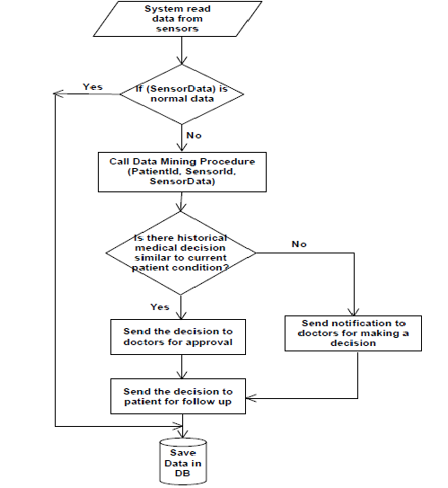

Figure 6.3 Flow Diagram.

**6.3 Graphical User Interface**

The main graphical user interface is an Android Application which communicates with the Raspberry pi board and also which notifies about the patient status. This application initially has a welcome login page for authentication with two buttons, namely login and clear. When the user enters the correct username and the password the login succeeds and redirects the application to the main page shows the graph of user heart rate and temperature. If either the username or the password is invalid, then it prompts the user to enter the correct credentials. Thus the user’s status such as Heart rate, Temperature, Location, RFID can be tracked both on the AWS and cell phone. Further the Android application also all user to look at the location from the Raspberry pi camera and capture the real time picture. The GUI has been planned to designed very efficiently so that it’s user friendly and at the same time has a good look and feel.

Also there is an monitor or laptop which is directly connected to the Raspberry pi board which provides a restricted user interface as it allows the user to only view the data being displayed on it and have complete control over the board using the VNC client module and this VNC control is also available on the Mobile in the form of Android application.

**6.4 Class Diagram**

* The relationship among various classes and their interdependencies are effectively modeled using the class diagram by using association, aggregation, composition and generalization, The components used for the Embedded module is considered has the separate class. This gives the clear conceptual understanding. which is shown in Figure.6.4

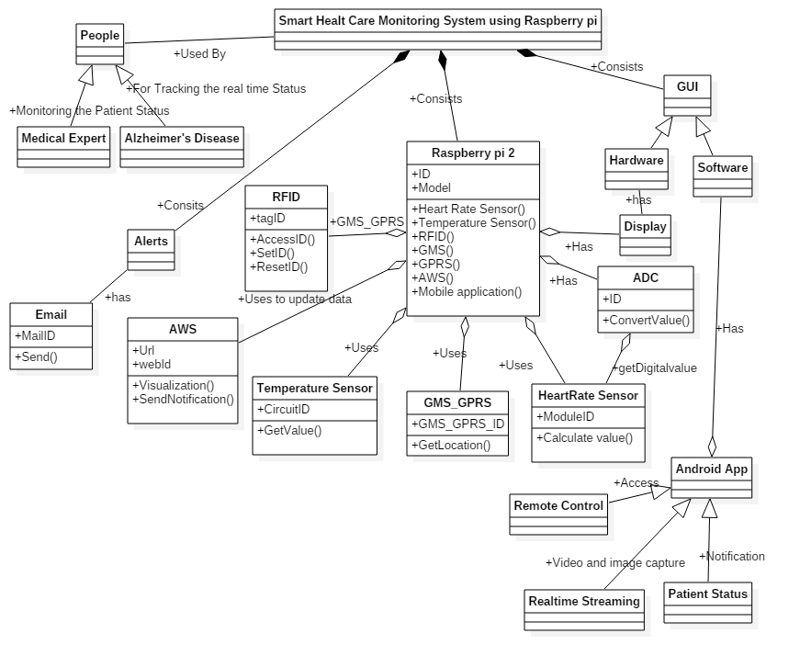

Figure 6.4 Class Diagram

Raspberry pi the main embedded module with various sensors integrated. Then data sensed will be pushed on to the AWS EC2 cloud desktop. Cloud desktop will forward the content received to android application.

**6.5 Sequence Diagram**

The sequence diagram Figure 6.5 described sequence of smart health care monitoring working with the step by step interaction. This module will start will RFID module, used for patient unique identity. Once the RFID module capture’s the 11 digit code, heart beat sensor, temperature sensor, GPRS and GSM module will start sensing the data. The sequence diagram Figure 6.6 shows the patient interaction and Figure 6.7shows the doctor interaction with the android app.

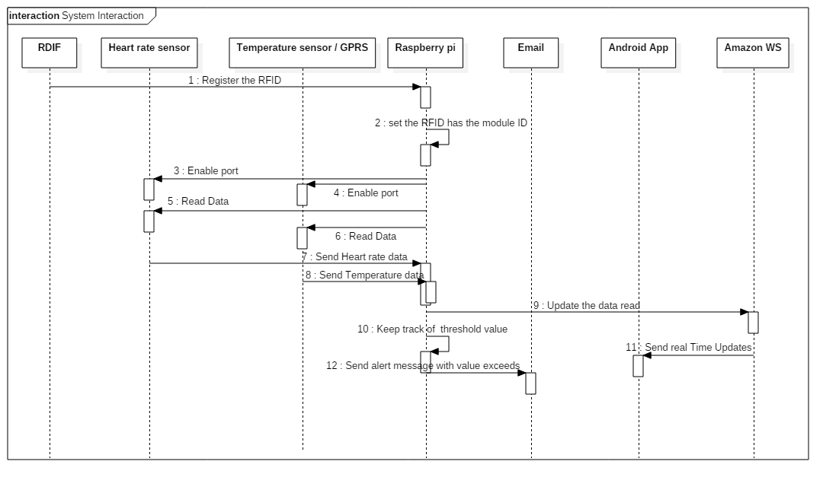

Figure 6.5 Sequence Diagram for Smart Health Care Monitoring.

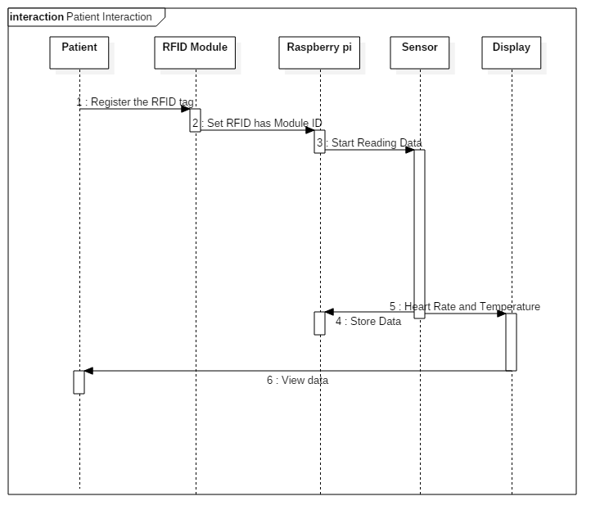

Figure 6.6 Sequence Diagram for Patient interaction.

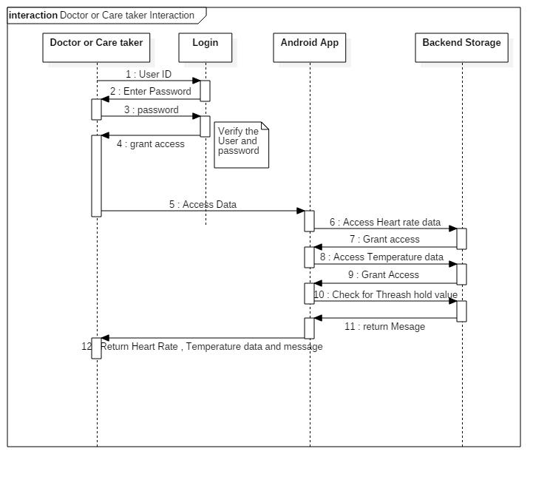

Figure 6.7 Sequence Diagram for Doctor Interaction.

**6.6 Data Flow Diagram**

A **data flow diagram** (**DFD**) is a graphical representation of the "flow" of data through an information system, modeling its process aspects. The data flow diagram in Figure 6.8 describes the complete flow of interaction .The execution starts scanning RFID tag, and then the port for sensors to work will be enabled. Data being read will be sent to the AWS server which is created with the EC2 instance. Android application provided will give the real time vital information to the intended person. A DFD shows what kind of information will be input to and output from the system .

**Untitled Diagram1.png**

Figure 6.8 Data Flow Diagram.

**6.7 Conclusion**

The system that we have proposed is light weight and can be used on a daily basis and will help in quick recovery. we presented an approach for Alzheimer patient tracking using the RFID tags and the GPS. We presented a system allowing having the relative position of the tag. Additionally we described how we can locate using the advantage of each technology. We furthermore present how to fabricate both of the elements: the tag and the reader. Finally, in practical our system can at the same time detect and build accurate maps sending data continually, otherwise knowing the position in real-time of people with Alzheimer disease. We are monitoring temperature and heart beat continuously .Based on the threshold value alert goes to family member and doctor along with location also. By sending an Email alert to the doctor along with the GPS position of the user it ensures that the user receives immediate care.

**Chapter 7**

**IMPLEMENTATION**

**7.1 Tools Introduction and Technology Introduction**

In project implementation or project execution, we put it all together. Project planning is complete, as detailed as possible, yet providing enough flexibility for necessary changes. In a customer-contractor relationship, the contract is signed, based on the right decisions about the contract structures, and including clauses for change and claim management. Objectives of the Implementation Phase is Putting the [action plan](http://www.sswm.info/category/planning-process-tools/decision-making/decision-making-tools/planning-community/community-a) into operation, Achieving tangible change and improvements, Ensuring that new infrastructure, new institutions and new resources are [sustainable](http://www.sswm.info/glossary/2/letters#term999) in every aspect, Ensuring that any unforeseen [conflicts](http://www.sswm.info/category/planning-process-tools/decision-making/decision-making-tools/deciding-community/conflict-ma) that might arise during this stage are resolved, Ensuring transparency with regard to [finances](http://www.sswm.info/category/planning-process-tools/implementation/implementation-support-tools/financing/financing-and-), Ensuring that potential benefits are not captured by elites at the expenses of poorer social groups . This project uses various tools like.

**Angry IP scanner**: which is used to scan the IP address of device through the same shared connection, mainly we use this identify the IP address of the Raspberry pi, which is used during wireless interface, consider figure 7.1.

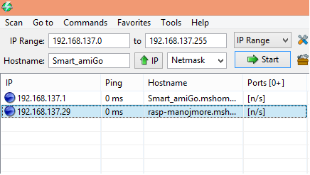

Figure 7.1 Angry IP scanners

**Putty**: Putty is an SSH and telnet client, developed originally by Simon Tatham for the Windows platform. Putty is open source software that is available with source code and is developed and supported by a group of volunteers. Bitwise SSH Client is an SSH and SFTP client for Windows. It is developed and supported professionally by Bitwise. The SSH Client is robust, easy to install, easy to use, and supports all features supported by Putty. This gives you the terminal interface to the raspberry pi board where Linux command can be executed; consider figure 7.2 and 7.3 which shows Putty setup and Putty Terminal.

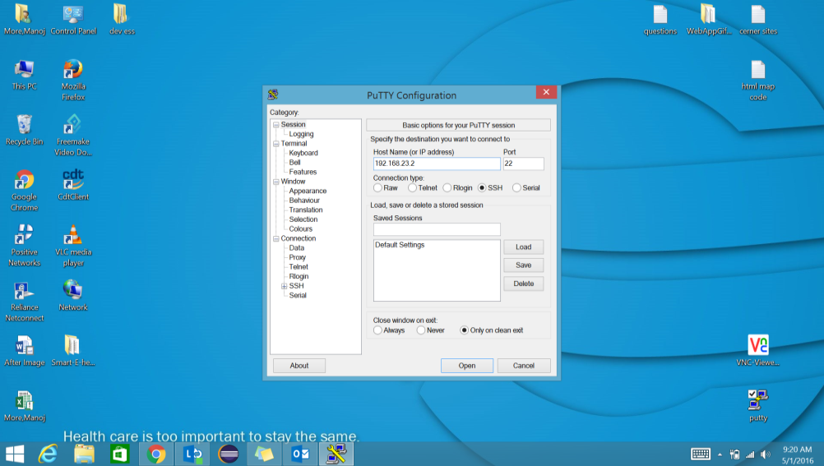

Figure 7.2 Putty setup

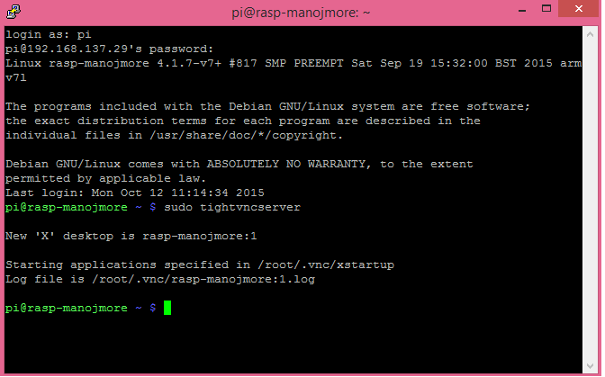

Figure 7.3 Putty Terminals.

**VNC viewer**: A **VNC viewer** is a program that shares a desktop with other computers over the Internet. You will need a **VNC viewer** if you want other people to see you’re desktop. VNC Server for Windows is designed to run either in User-Mode, as a personal per-user server, or in Service-Mode, as a system service available whether or not there is a user logged in. VNC viewer provides the GUI interface to the Raspberry pi, consider figure 7.4, 7.5 and 7.6 for complete configuration and setup of VNC.

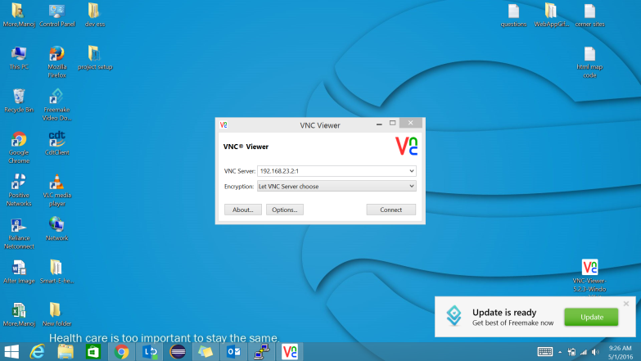

Figure 7.4 VNC configurations.

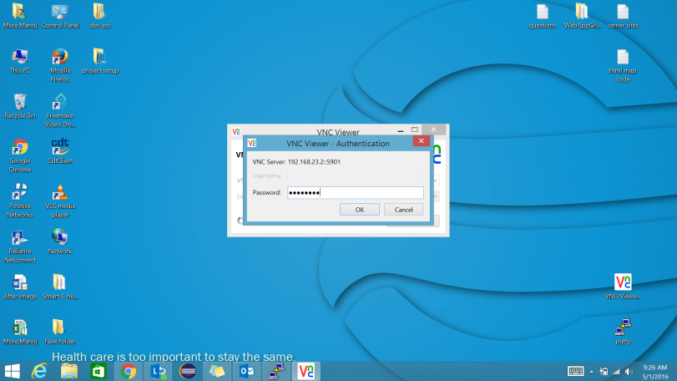

Figure 7.5 VNC Authentications.

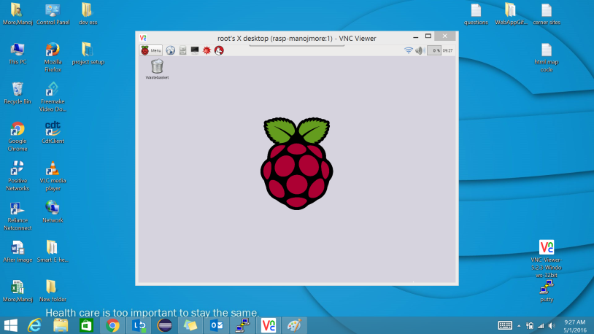

Figure 7.6 VNC viewer Virtual window.

**Flash magic**: Flash Magic is a PC tool for programming flash based microcontrollers from [NXP](http://www.nxp.com/microcontrollers) using a serial or Ethernet protocol while in the target hardware.  GSM Terminal to check the connection status, consider figure 7.7 and 7.8 which shows Flash magic terminal settings and terminal.

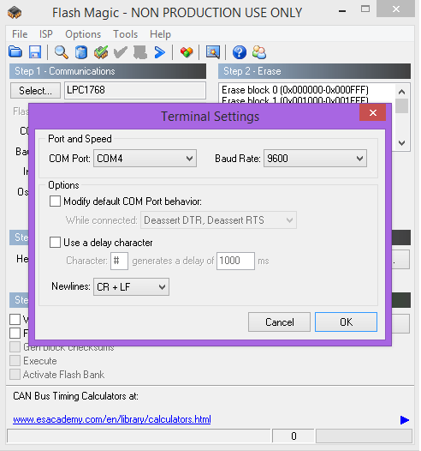

Figure 7.7 flash magic terminal settings.

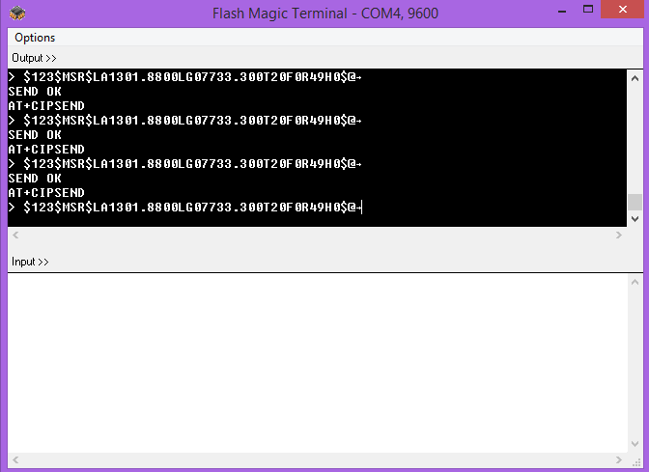

Figure 7.8 flash magic terminal.

**AWS EC2 and RDB service** : This is used has the server where data from the hardware module is send to the cloud server and then from there by making use of TCP listener application the data is sent to android app through port 85, consider figure 7.9 and 7.10 which tells about EC2 and cloud desktop view.

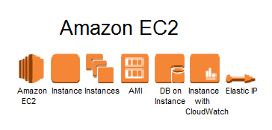

Figure 7.9 Amazon EC2

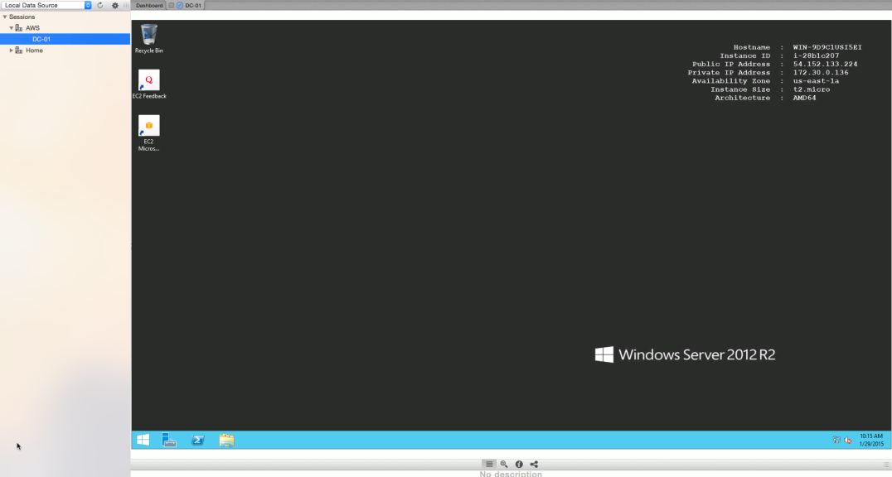

Figure 7.10 Cloud desktop

**7.2 Overall view of the project in terms of implementation**

The Raspberry Pi is a low cost, credit-card sized computer that plugs into a computer monitor or TV, and uses a standard keyboard and mouse. It is a capable little device that enables people of all ages to explore computing, and to learn how to program in languages like Scratch and Python. It’s capable of doing everything you’d expect a desktop computer to do, from browsing the internet and playing high-definition video, to making spreadsheets, word-processing, and playing games, Raspberry pi has 40 pin gpio pin and takes 5 volt input power supply. Renesas board comes various pin configurations and it takes constant 12 volt power supply. What is the reason for interfacing Raspberry pi and Renesas?, raspberry pi don’t have the built in ADC ,which has capability of reading only digital output’s. so to deal with the sensors which give analog output we are making use renesas board which comes with the built ADC and major advantage of using renesas is we will get extra GPIO pins which can be used integrate few more sensor. Raspberry pi and Renesas board are interfaced together, where sensor like GSM, heart beat sensor which need 3.3 – 5 volt input power supply are connected to raspberry pi and GPRS, temperature sensor and accelerometer sensor which need greater than 5 volt are connected to the renesas and the output pin of the renesas is given to raspberry pi, where serial data transmission takes place between renesas and raspberry pi. Consider the figure 7.11.



Figure 7.11 Complete hardware Implementation

**7.3 Algorithm Design**

Input: Raspberry Pi with all the Sensor connections.

Output: Updating Heart Rate Sensor values and Temperature value to AWS and Android Application Module, sending Email Alert.

1. R 🡨 Raw data from the Heart Rate sensors.
2. Ra 🡨 P (R) // parsing the raw data to obtain the actual analog voltage values.
3. Rd 🡨 ADC (Ra) //Converting to digital voltage value.
4. Monitor (Rd) /* Displaying appropriate messages and digital voltage value on Monitor. */
5. App 🡨 Rd // Send data to Android Application.
6. Loop (Keep Track of Threshold value Being Sensed)

Send Alert on Android Application.

Send Email Alert using phone’s Internet with location as attachment.

Buzzer 🡨 ON

1. If (Temperature Exceeds)

Variable1 🡨 Store Time, Date and Location.

Wc++

1. Else IF (Heart Rate Data Exceeds)

Variable2🡨 Store Time, Date and Location.

Wc++

1. Loop back to step 1.

**7.4 Information about the Implementation of Modules**

**Heart beat sensor TCRT1000**

TCRT 100 works based on the principle of photoplethysmography (PPG) which is a non-invasive method of measuring the variation in blood volume in tissues using a light source and a detector. Since the change in blood volume is synchronous to the heart beat, this technique can be used to calculate the heart rate. Transmittance and reflectance are two basic types of photoplethysmography. For the transmittance PPG, a light source is emitted in to the tissue and a light detector is placed in the opposite side of the tissue to measure the resultant light. Because of the limited penetration depth of the light through organ tissue, the transmittance PPG is applicable to a restricted body part, such as the finger or the ear lobe. However, in the reflectance PPG, the light source and the light detector are both placed on the same side of a body part. The light is emitted into the tissue and the reflected light is measured by the detector. As the light doesn’t have to penetrate the body, the reflectance PPG can be applied to any parts of human body. In either case, the detected light reflected from or transmitted through the body part will fluctuate according to the pulsatile blood flow caused by the beating of the heart; consider the following figure 7.12 and 7.13 which shows working and circuit diagram.

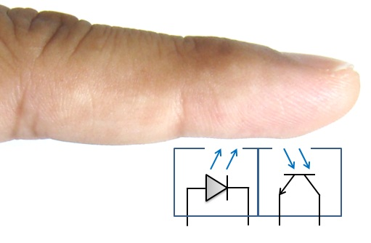

Figure 7.12 TCRT1000 working

Figure 7.13 TCRT1000 pin circuit

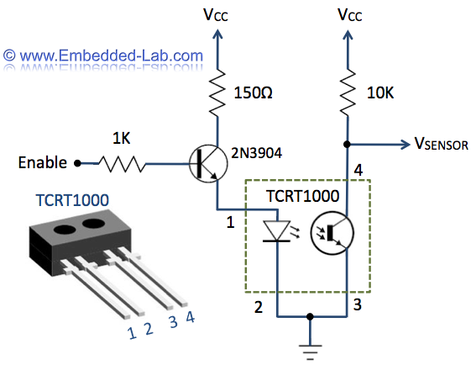

**Accelerometer**

An accelerometer is an electromechanical device that will measure acceleration forces. These forces may be static, like the constant force of gravity pulling at your feet, or they could be dynamic - caused by moving or vibrating the accelerometer, figure 7.14 shows accelerometer sensor.

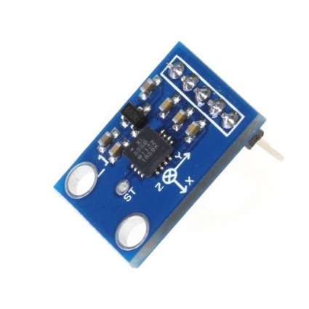

**Figure 7.14 Accelerometer**

**GSM and GPRS module**

**GSM/GPRS module** is used to establish communication between a computer and a **GSM-GPRS system. Global System for Mobile communication (GSM)** is an architecture used for mobile communication in most of the countries. **Global Packet Radio Service (GPRS)**is an extension of GSM that enables higher data transmission rate.

**RFID module**

The RFID device serves the same purpose as a bar code or a magnetic strip on the back of a credit card or ATM card; it provides a unique identifier for that object. And, just as a bar code or magnetic strip must be scanned to get the information, the RFID device must be scanned to retrieve the identifying information, figure 7.15 shows circuit of RFID module.



Figure 7.15 circuit module

**Temperature sensor LM35**  
The LM35 series are precision integrated-circuit temperature devices with an output voltage linearly-proportional to the Centigrade temperature. The LM35 device has an advantage over linear temperature sensors calibrated in Kelvin, as the user is not required to subtract a large constant voltage from the output to obtain convenient Centigrade scaling figure 7.16 shows circuit of LM35



Figure 7.16 LM35

**7.5 Conclusion**

Towards the end of project implementation phase, the desired result of the project takes more and more shape: we integrate, test, and commission last sub-parts. The end product or service is **essentially** put together. Then, we declare the project result "ready for preliminary acceptance".

**Chapter 8**

**TESTING**

**8.1 Introduction**

Software testing is defined as “A process of executing a program or application with the intent of finding the software bugs”. It can also be stated as “The process of validating and verifying that a software program or application or product meets the business and technical requirements that guided its design and development, works as expected and can be implemented with the same characteristic”.

In our project we have used Python programming language for programming and interfacing the Heartbeat, temperature sensor, GPS and GSM with the Raspberry pi board, and Java for developing the Android application. Thus we used Junit framework for testing the various components of the application and a tool called Flash Magic was used for testing the GSM module. The android application, it was automated using Junit framework. JUnit is a “unit testing framework for the Java programming language. JUnit has been important in the development of test-driven development, and is one of a family of unit testing frameworks collectively known as xUnit that originated with Junit”.

Also the Android Virtual Device Manager (AVD) was used to perform integration testing on the unit tested components of the Android application. An Android Virtual Device (AVD) is “an emulator configuration that lets you model an actual device by defining hardware and software options to be emulated by the Android Emulator”. Apart from performing functional testing AVD also aids in nonfunctional testing (compatibility/portability testing) as it can simulate different android phones from brands like Nexus, Samsung, and Nokia etc.

A framework called Robotium has been used for performing automated testing on the Android Application in conjunction with Junit. Robotium is “An open-source test framework for writing automatic gray box testing cases for Android applications.

With the support of Robotium, test case developers can write function, system and acceptance test scenarios, spanning multiple Android activities”. When running the test case on the emulator or an actual device, you will see the values being entered into the UI components or see them being clicked as if you were doing it yourself. After the tests are completed, the JUnit view in Eclipse will show which tests have failed and passed.

**8.2 Testing Tools and Environment**

The different testing tools and environment used are as follows:

1. Flash Magic: This tool is used to unit test the HC05 Bluetooth module to ensure that the process of sending and receiving messages via HC05 works correctly.
2. Junit: It’s a unit testing framework used for testing different components of the Android Application. Various test cases can be run and assertions can be made to indicate if the tests failed or succeeded.
3. Robotium: This framework is used for automating test cases. When running the test case on the emulator or an actual device, you will see the values being entered into the UI components or see them being clicked as if you were doing it yourself. After the tests are completed, the JUnit view in Eclipse will show which tests have failed and passed.
4. Android Virtual Device Manager: This simulates the environment for running an android application and has been used to test SMS module and login module.

**8.3 Test Cases**

1. **Pairing to GSM Module and Transfer data (Using Flash magic)**

|  |  |
| --- | --- |
| **Test Case ID.** | 1 |
| **Test Case Objective** | Connect to device |
| **Execution steps** | Execute Connection command |
| **Test Input** | NA |
| **Expected Output** | Device Paired |
| **Passed(?)** | Yes |

Table 8.1 Unit Test Case 1

Software called Flash Magic can be used to test the GMS module. By shorting the Rx and Tx pins i.e. the receiver and the transmitter pins GSM, the message that is sent is delivered to destination server, we are diverting data to the Amazon cloud desktop itself. Once the devices are paired, messages can be sent depending on the heart beat sensor values, GPS location value, Temperature Sensor value. Has discussed above when we are making use of flag magic tool , we need to set the COM port number through which the GSM commands will be sent and this COM value may vary from com1 – com14 and etc, the COM port used can be found in device manager/ports section, fig 8.1 shows the flash magic setup .Once the flash magic setup is done then window looks like a Terminal has shown in fig 8.2.



Figure 8.1. Testing GSM setup Using Flash Magic



Figure 8.2. Testing GSM Using Flash Magic

1. **Login to Android Application (Using Android Virtual Device)**

|  |  |
| --- | --- |
| **Test Case ID.** | 2 |
| **Test Case Objective** | Enter invalid password and/or invalid username |
| **Execution steps** | Click Login |
| **Test Input** | Password:***  Username: User1 |
| **Expected Output** | Login Failed |
| **Passed(?)** | Yes |

Table 8.2 Unit Test Case 2

|  |  |
| --- | --- |
| **Test Case ID.** | 3 |
| **Test Case Objective** | Enter correct password& correct username |
| **Execution steps** | Click Login |
| **Test Input** | Password:*****  Username: admin |
| **Expected Output** | Login Successfully, Allow user to proceed |
| **Passed(?)** | Yes |

Table 8.3 Unit Test Case 3

|  |  |
| --- | --- |
| **Test Case ID.** | 4 |
| **Test Case Objective** | Clear Data in the fields |
| **Execution steps** | Click Cancel |
| **Test Input** | NA |
| **Expected Output** | Data Cleared |
| **Passed(?)** | Yes |

Table 8.4. Unit Test Case 4

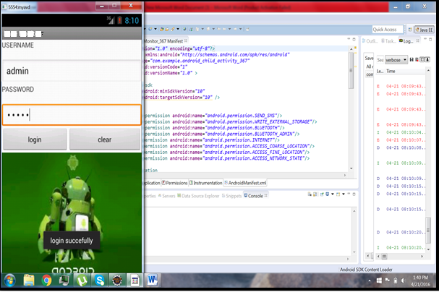

Figure 8.3 Testing using AVD

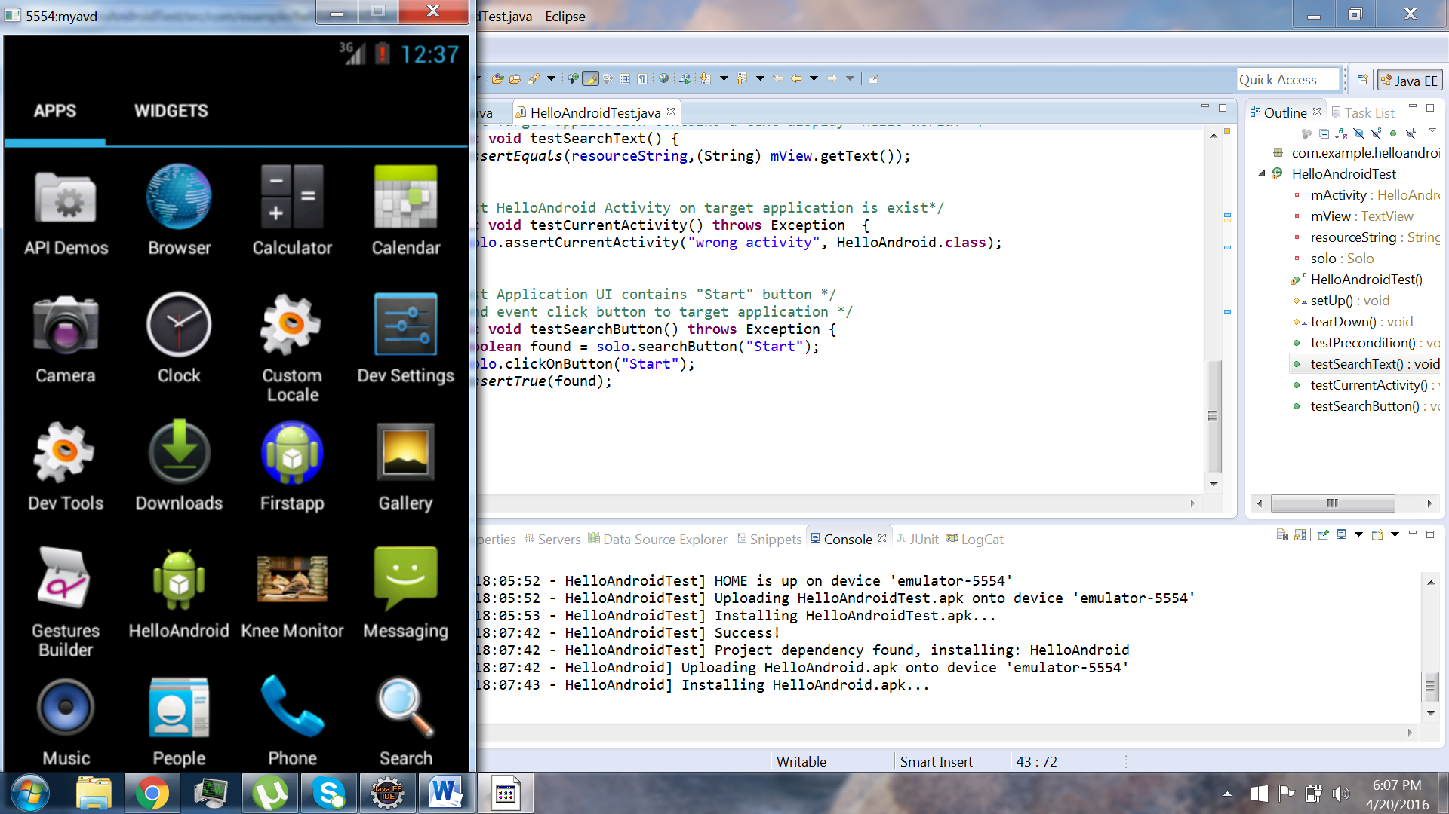

Figure 8.4 Junit Testing

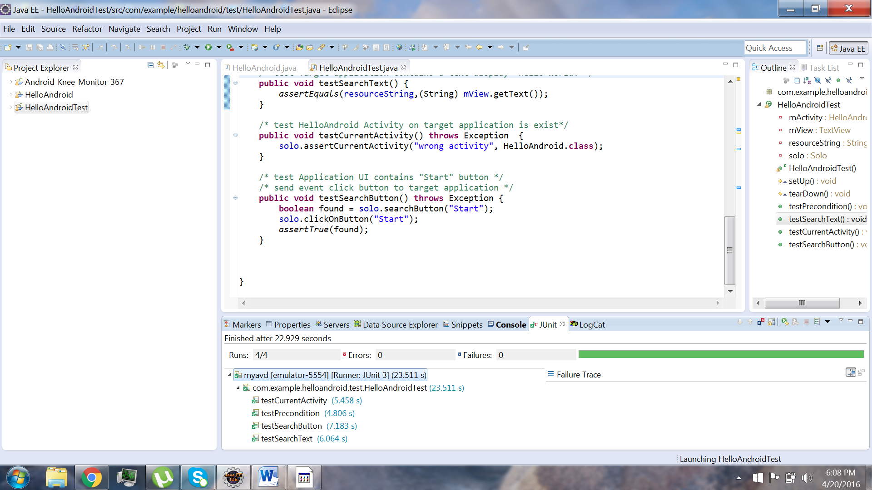

Figure 8.5 Junit Testing (Success)

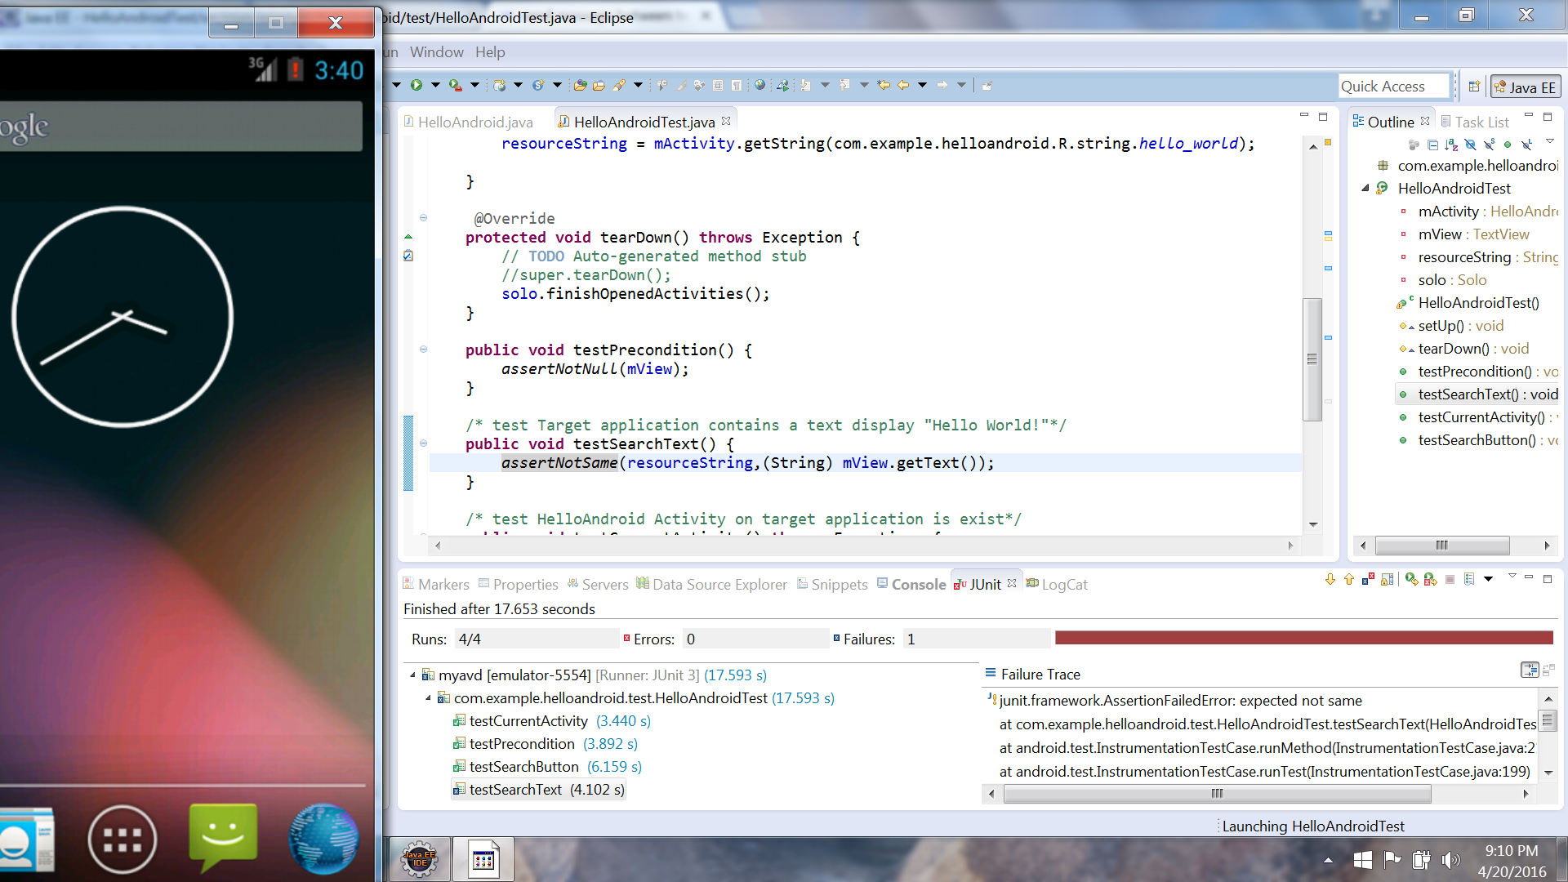

Figure 8.6 Junit Testing (Fail)

1. **Android Application’s Portability/Compatibility (Using Android Virtual Device)**

|  |  |
| --- | --- |
| **Test Case ID.** | 5 |
| **Test Case Objective** | Check if app runs on various phones |
| **Execution steps** | Run in AVD with different Android versions and phones |
| **Test Input** | NA |
| **Expected Output** | All features of the app are working |
| **Passed(?)** | Yes |

Table 8.5 Unit Test Case 5

|  |  |
| --- | --- |
| **Test Case ID.** | 6 |
| **Test Case Objective** | Check GPRS Location,Latitude,Longitude |
| **Execution steps** | Execute the code |
| **Test Input** | Power supply |
| **Expected Output** | If signal available,Output latitude,longitude |
| **Passed(?)** | Yes |

Table 8.6 Unit Test Case 6

|  |  |
| --- | --- |
| **Test Case ID.** | 7 |
| **Test Case Objective** | Check heart rate sensor |
| **Execution steps** | Place your thumb finger inside heart rate sensor |
| **Test Input** | Pulse count=5 |
| **Expected Output** | Heart beat=71 |
| **Passed(?)** | Yes |

Table 8.7 Unit Test Case 7

|  |  |
| --- | --- |
| **Test Case ID.** | 8 |
| **Test Case Objective** | Check heart rate sensor |
| **Execution steps** | Place your thumb finger inside heart rate sensor |
| **Test Input** | Pulse count=6 |
| **Expected Output** | Heart beat=72 |
| **Passed(?)** | Yes |

Table 8.8 Unit Test Case 8

|  |  |
| --- | --- |
| **Test Case ID.** | 9 |
| **Test Case Objective** | Check heart rate sensor |
| **Execution steps** | Place your thumb finger inside heart rate sensor |
| **Test Input** | Pulse count=7 |
| **Expected Output** | Heart beat=73 |
| **Passed(?)** | Yes |

Table 8.9 Unit Test Case 9

|  |  |
| --- | --- |
| **Test Case ID.** | 10 |
| **Test Case Objective** | Identify the variation in heart beat |
| **Execution steps** | Place your thumb finger inside heart rate sensor |
| **Test Input** | Varying Pulse count |
| **Expected Output** | Rise and fall in heart rate |
| **Passed(?)** | Yes |

Table 8.10 Unit Test Case 10

|  |  |
| --- | --- |
| **Test Case ID.** | 11 |
| **Test Case Objective** | Storing read Data on cloud using AWS |
| **Execution steps** | Data read from sensor is converted into string and set by gprs sent command |
| **Test Input** | Read Data |
| **Expected Output** | Data inserted in respective table successfully |
| **Passed(?)** | Yes |

Table 8.11 Integration Test Case 1

|  |  |
| --- | --- |
| **Test Case ID.** | 12 |
| **Test Case Objective** | Showing Live reading on Android Application |
| **Execution steps** | Data stored in cloud is sent to android app |
| **Test Input** | Login to Application |
| **Expected Output** | Live Data Retrieved successfully |
| **Passed(?)** | Yes |

Table 8.12 Integration Test Case 2

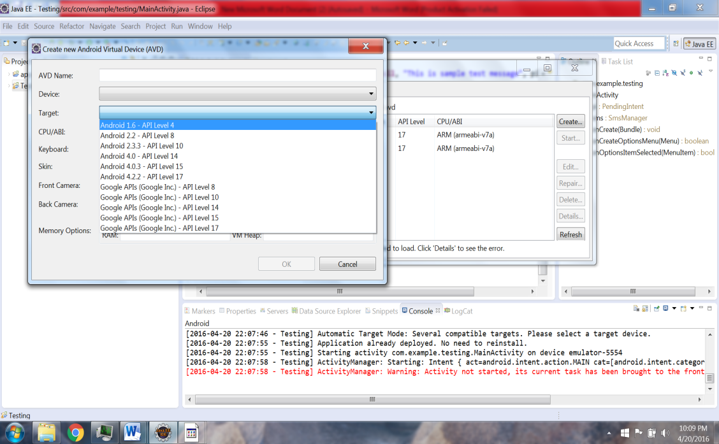

Figure 8.7 Different Phone Models (AVD)

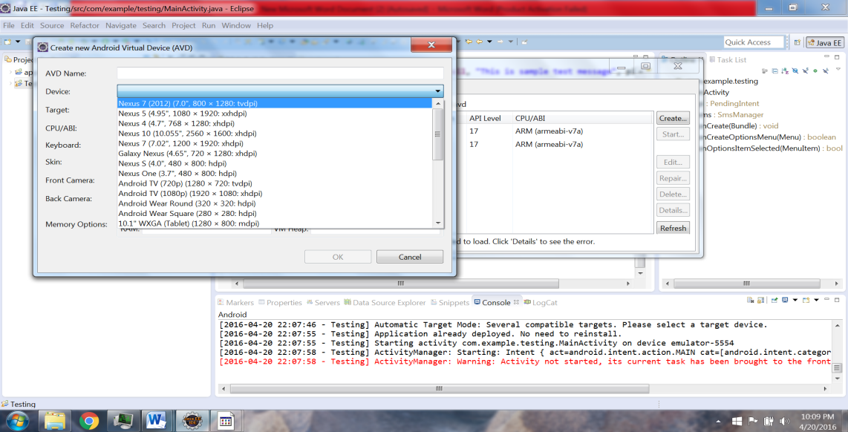

Figure 8.8 Different OS versions (AVD)

1. **Testing Interfaced Hardware components**

The hardware testing is done manually using the Flash magic which is used to check the GSM connectivity and command execution. The purpose of this test program is to display a command execution response before we proceed towards local desktop server module this is done to ensure that it’s been interfaced properly with the Raspberry pi module. Later this program is extended to read the values from the Heart beat sensors, GPS sensor, and Temperature sensor and to display these values on the monitor.

**8.4 Module Wise Defects Distribution**

1. Android Application

* Login page: Invalid Username or password and sending the data read from the hardware module.

1. Heart beat Sensor

* The Heart beat sensor will read null value if sensor is not integrated on body.

1. Temperature Sensor

* The temperature sensor will read room temperature if the sensor is not integrated on body.

1. GSM Module

* Need SIM Activated with data pack to divert the data.

1. GPS Module

* Takes long delay to get configured and generate Null value when Signal lost.

**8.5 Major Challenges**

|  |  |  |  |  |
| --- | --- | --- | --- | --- |
| **Sl. No.** | **Module** | **Description** | **Severity** | **Status** |
| 1 | Hardware Interface to Laptop | Wired, Interface the Hardware module to the laptop. Wireless Interface to the same | High | Resolved |
| 2 | Temperature Module | Convert the Analog data to digital and forward the same to Raspberry pi | High | Resolved |
| 3 | GPS Module | Takes long delay to get configured and generate Null value when Signal lost | Low | Active |
| 4 | Relay | Switch between RFID reading module and data sensor module | High | Resolved |

Table 8.13 Major Challenges

**8.6 Levels of Testing Performed**

1. **Gray box automated testing:** Robotium is open source gray box automated testing tool that has been used for running 4 test cases on the android application. Automated testing tools “Are capable of executing tests, reporting outcomes and comparing results with earlier test runs. Tests carried out with these tools can be run repeatedly, at any time of day”. Thus Gray-box testing is a combination of white-box testing and black-box testing. The aim of this testing is to search for the defects if any due to improper structure or improper usage of applications.
2. **Manual Testing:** In order to test the hardware components such as Temperature module, GSM, GPS location etc. In manual testing the tests aren’t executed by machines. Instead they need to be carried out physically.
3. **Unit Testing:** Junit is an open source unit testing framework which has been used for testing the module, running Robotium tests etc. In unit testing the individual modules are tested for their functionalities and are later integrated. test cases for unit testing are shown in table no: 8.1,8.2,8.3,8.4,8.4,8.5,8.6,8.7,8.8,8.9,8.10.
4. **Integration Testing:** Once the important modules have been unit tested, it’s followed by integration testing where multiple modules are combined together and are then tested using an Android virtual device.test cases for Integration testing are shown in table no:8.11 & 8.12.
5. **System Testing:** The entire system with all its modules together has been tested to ensure that all the features of the system work properly. This is done by integrating Raspberry pi with Heart beat sensor, Temperature sensor, and GPS/GSM module and by installing the apk file of the android application on a phone and then testing the entire system.
6. **Usability Testing:** The user friendliness of the android application and its GUI has been tested by using a AVD and also by installing and running the apk file on the phone.

**Chapter 9**

**CONCLUSION & SCOPE FOR FUTURE WORK**

The integration between wireless sensor networks and cloud computing will create a new generation of technology in many aspects such as patient monitoring with minimal cost, health alerts, etc. The system that is proposed is light weight so that it can be used on a daily basis and will help in quick recovery. The system presents an approach for Alzheimer patient tracking using the RFID tags and the GPS. System can detect and build accurate maps and can send it to the desired people during an emergency. Along with all the other features, the system also monitors the temperature and heartbeat of the patient. By sending an Email alert to the doctor and care taker along with the GPS position of the user it ensures that the user receives immediate care.

Further this functionality can be extended to monitor various other parameter of the patient by including other sensors. The concept of radio Doppler Effect can be used to read the patient vitals in the wireless mode so that just by making use of radio wave the data can be read.

**Chapter 10**

**REFERENCES**

[1] [online] <http://www.centrenational-rfid.com>.

[2] [online] www.alzfdn.org

[3] [online] http//www. arduino.cc/

[4] [online] <http://structuredmp.com/index.html>

[5] [online] www.livescience.com

[6] [online] www.medindia.net

[7] [online] www.modsci.org

[8] [online] [www.amazon.com/ec2](http://www.amazon.com/ec2)

[9] [online] [www.amazon.com/rds](http://www.amazon.com/rds)

[10] [online] www.mayoclinic.org

[11] [online]www.hopkinsmedicine.org

[12] Skubic, M., Guevara, R. D., & Rantz, M. (2015). Automated health alerts using in-home sensor data for embedded health assessment. *Translational Engineering in Health and Medicine, IEEE Journal of*, *3*, 1-11.

[13] Nikhade, S. G. (2015, May). Wireless sensor network system using Raspberry Pi and zigbee for environmental monitoring applications. In *Smart Technologies and Management for Computing, Communication, Controls, Energy and Materials (ICSTM), 2015 International Conference on* (pp. 376-381). IEEE.

[14] Jassas, M. S., Qasem, A. A., & Mahmoud, Q. H. (2015, May). A smart system connecting e-health sensors and the cloud. In *Electrical and Computer Engineering (CCECE), 2015 IEEE 28th Canadian Conference on*(pp. 712-716). IEEE..

[15] Li, D. (2015, May). A wireless tracking system for at-home medical equipment during natural disasters. In *Systems, Applications and Technology Conference (LISAT), 2015 IEEE Long Island* (pp. 1-6). IEEE.

[16] Finkenzeller, K., & Handbook, R. F. I. D. (1999). Radio-frequency identification fundamentals and applications. *Chippenham: John Wiley & Son*.

[17] Budiharto, W. (2014, August). Design of tracked robot with remote control for surveillance. In *Advanced Mechatronic Systems (ICAMechS), 2014 International Conference on* (pp. 342-346). IEEE.

[18] Lymberis, A. (2003, April). Smart wearables for remote health monitoring, from prevention to rehabilitation: current R&D, future challenges. In*Information Technology Applications in Biomedicine, 2003. 4th International IEEE EMBS Special Topic Conference on* (pp. 272-275). IEEE.

[19] Warren, S., Craft, R. L., & Bosma, B. (1999, April). Designing smart health care technology into the home of the future. In *Workshops on Future Medical Devices: Home Care Technologies for the 21st Century* (Vol. 2, p. 667).

[20] Rao, P. B., & Uma, S. K. (2015). Raspberry Pi Home Automation With Wireless Sensors Using Smart Phone. *International Journal of Computer Science and Mobile Computing*, *4*(5), 797-803.

[21] Khelil, A., Shaikh, F. K., Sheikh, A. A., Felemban, E., & Bojan, H. (2014, November). Digiaid: A wearable health platform for automated self-tagging in emergency cases. In *Wireless Mobile Communication and Healthcare (Mobihealth), 2014 EAI 4th International Conference on* (pp. 296-299). IEEE.